# Clinical Genetics Waiting List – the Pandemic Perspective

*Dr Shane McKee, Consultant in Genetic & Genomic Medicine, Clinical Lead (Non-Cancer) Genetics.*

**V0.1 31/5/2021** [This is a work in progress – a little narrative to set out where we were, what we were faced with, what we decided, what we did, and what happened next.]

### Introduction

The Covid-19 Pandemic has landed unprecedented stress on our health system, as well as on wider society and in particular patients and families directly affected. Northern Ireland’s waiting lists going into the Pandemic were in a parlous state, and as we emerge (hopefully) from the disaster of the last year, in most areas things have got worse – sometimes considerably. Northern Ireland’s outpatient and surgical waiting lists are far and away the worst in the UK and Ireland.

The Northern Ireland Regional Genetics Service provides clinical and laboratory genetic services for patients with Rare Diseases. A Rare Disease is one which affects fewer than 1 per 2000 people in the population, but because there are thousands of them, a House of Lords report estimated that one person in 17 is affected, which collectively makes this a huge area of need. Most of these conditions are genetic, and children are disproportionately affected; many are lifelong or very long term, treatments (where those exist) are often expensive, or the conditions themselves may be considerably debilitating. Taking all this together, it is apparent that Rare Diseases collectively pose some of the largest challenges to our health system. Diagnosis of the specific Rare Disease affecting a child is often a very challenging process, and may involve multple investigations over several years, constituting a “diagnostic odyssey”.

In addition to patients with Rare Diseases, referrals to the NIRGS include many patients with family histories of cancer. These patients need risk assessment, matching to surveillance programmes, and potentially genetic testing, both diagnostic and predictive (i.e. to determine whether they carry a gene variant predisposing to cancer). Referrals to the service come from both primary and secondary care.

NIRGS is a regional service covering the whole of Northern Ireland, based at Belfast City Hospital, within Belfast HSC Trust. It consists of clinical (doctors and Genetic Counsellors), laboratory (clinical scientists and other lab staff), and administrative staff. Referral rates to the clinical service over the past few years are illustrated later in this document.

Going into the pandemic, the waiting list for first appointments at a Genetics Clinic was not in a healthy place, with 1130 patients awaiting a first appointment by 31 December 2019. It was very clear that even though a drop in referrals could be anticipated, action needed to be taken to get the waiting list backlog into shape, so that when we emerged from the pandemic, patients would not have to wait as long.

## Actions taken

Having said all that, it was not immediately obvious what actions could be taken. The service was already one consultant down, a recruitment exercise to appoint a replacement for a retired colleague having been unsuccessful. The immediacy of the pandemic meant that we had to move quickly and “suck it and see”.

Most of the measures we undertook were instituted together, without a specific focus on benchmarking, and without rigorous PDSA evaluation – there just wasn’t time. In retrospect, perhaps we *could* have done this in a more planned fashion, so that is a potential lesson to learn. However, a crucial part of our strategy was *making the data visible*. The staff could see the shape of the waiting list, and moreover could go into the list itself to click on individual patients to see what needed done.

1. **Re-triage:** using NIECR we were able to go back into patients’ referral information to see why they had been referred, and determine what needed to happen next.
2. **Write back with advice, and discharge:** It was evident that some patients did not need to physically attend a clinic, but rather could be handled appropriately with advice back to the referrer.
3. **Arrange bloods/testing up-front:** It was clear from NIECR that some patients needed certain investigations carried out – often this could be arranged, either via the referrer, the phlebotomy hubs or by another clinic, thereby avoiding patients needing multiple attendances.
4. **Implement virtual clinics:** When face-to-face clinics were cancelled due to the First Lockdown, Genetics pivoted rapidly to a Virtual Clinic model, with most appointments being converted to telephone. One consultant carried out a considerably number of video clinics using Teams; unfortunately the old PCs that most Genetics staff were using prevented more widespread adoption of this. A number of patients had been retained as “face-to-face" following an earlier retriage exercise in April 2020. We decided later in 2020 that ALL patients should be offered a virtual appointment, but if face-to-face became available for certain patients, they could be offered those instead. This allowed us to clear the “longest waiters” by mid-January 2021.
5. **Redirect to appropriate specialty:** Some triaged referrals were not really appropriate for a genetics consultation (e.g. joint hypermobility without other features suggestive of a genetic disorder). These patients were either appropriately redirected, or written back to with advice, with the potential for re-referral if other features became apparent.
6. **Assign patients to appropriate clinic (grouping):** grouping allows certain common features to be assessed and dealt with, even though the patients are being “seen” (virtually) separately.
7. **Identify re-referred review patients** & institute appropriate management: A surprisingly high number of patients were on the New Patient list who had already been seen by one of the Genetics Team – they were actually a Review patient. Identifying these patients meant that their consultant could decide what action needed taken – very often a quick phone call or arranging further tests on a stored DNA sample was all that was required, and they could come off the list.
8. **Identify longest waiters** and actively explore options: Specifically looking at those patients who had been waiting longest allowed us to address the issues that were preventing them from being seen. Finding interpreters was frequently a problem – we solved this by using phone interpreters or by using suitable vetted family members.
9. **See family members together:** some individuals in a family had been referred separately, but for the same problem. Very often in our experience, patients are very happy to be seen together in the same slot (although they can be seen separately if they wish). This allowed us to free up additional space in virtual clinics.
10. **Virtual clinics freed up extra slots:** Because there was no need to travel to an external clinic, the time freed up allowed us to add in some additional slots to some clinics. Also, we have found that virtual clinics are much easier to keep to time than physical clinics, so patients do not have to wait to the same extent as before.
11. **Reduction in DNA / UTC (“unable to contact”):** NIECR typically contains several contact numbers for patients, which meant that we could nearly always get in contact with the patient, reducing the proportion of “DNAs”. (Note, the actual return figures are currently being analysed, and this rate may be smaller than we had initially thought)
12. **Staff visibility of waiting list acts as a motivator:** We found that staff being actually able to visualise the waiting list backlog allowed them to plan better, and to be better prepared for their virtual clinics.
13. **Close engagement with the Appointments Office team:** Having a dedicated Appointments Officer looking after our clinic bookings was invaluable. This meant that vacant slots were rapidly filled, and patients were able to avail of the slots that suited them best.
14. **Decrease in Reviews created extra slots for New patients:** This is a potential issue for the coming year, as many patients who would have needed face-to-face review appointments have had their reviews postponed, often replaced by a phone call or an email. When things return to nearer to “normal”, this actual backlog is likely to impact on the sustainability of the waiting list reduction, and we may see waiting times begin to rise again.

### Progress of waiting list over the pandemic.

At the start of the “first lockdown”, the Genetics waiting list was not in a good place. Relevant features in the following graphs are the number of patients on the list (X-axis), the length of time they have been waiting (Y-axis) and the shape of the rank graph. The graphs show the rank position of each patient on the waiting list backlog **without** an appointment (X) versus the time they have been waiting (Y).

The graph from March 2020 shows patients ranked in order of referral by how long they had been waiting, so the longest waiter had been waiting almost 60 weeks for an appointment, and there were over 1000 patients overall on the list. Note – these are patients after the routine cancer family history referrals had been removed from the list, as these patients are generally dealt with by Genetic Counsellors, followed up by discussion with the consultants where appropriate.

Note: steepening of curve at around 19 weeks reflects drop in referrals due to first lockdown. An emerging “cliff” at around 53 weeks is starting to emerge following a retriage exercise focusing on more recently-referred patients. Longest waits are increasing for patients where virtual clinics were felt to be difficult, but face-to-face availability was severely constrained.

By November we still had a lot of people waiting more than 52 weeks, but the overall numbers were steadily reducing. The graph was starting to look like Cave Hill. However it was clear that the potential to get past “the cliff” meant that waiting times would fall considerably. We projected that we would clear this by mid-January; this was a little optimistic, as it proved difficult to get several patients sorted out. However the overall numbers on the waiting list continued to fall.

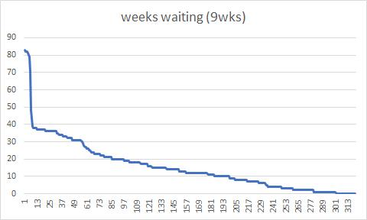

**[Above: Waiting list at 2 February 2021]**

By March we had cleared the “cliff”. Concerted action by all, and continuing with the Virtual Clinics, as well as re-starting several face-to-face clinics, resulted in a further improvement in that all patients waiting over 14 weeks had been seen.

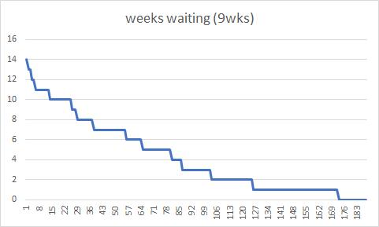

**[Above: Waiting list at 5/5/2021]**

The current waiting list backlog is now (May 2021) in a much healthier position, with the majority of patients receiving an appointment well before 9 weeks have elapsed since their referral. There is still work we can do to improve this, and we continue to apply Active Triage (including using the e-Triage system in NIECR for Primary Care referrals) and targeted intervention as appropriate.

## Progress indicators

It is possible to analyse the above data further to extract additional insights. We developed a number of Progress Indicators to allow us to do this.

The standard progress indicator provided to clinical teams is of the longest waiter, I.e. how long the longest waiter on the list has been waiting. The choice of this indicator was originally based on the somewhat naïve assumption that patients would (or even could) be “seen” in strict order of when they were “placed on the waiting list” (I.e. added to the backlog). This assumption is often wrong for reasons which are worth discussion elsewhere, and this can mask how well or how badly things are going further down the backlog. We adopted a number of metrics to try to get a more informative view of the state of the backlog.

* **LONGEST_WKS** – the wait time of the longest waiter (as above) - orange line, LEFT axis.
* **WL_TOT** – the total number of patients on the waiting list – light-blue line, RIGHT axis
* **WK_100** – the wait time of the 100th-longest-waiting patient on the list (this allowed us to see past the masking effect of LONGEST_WKS) - grey line, LEFT axis
* **RANK_9WK** – the position in the backlog of the first patient to be waiting just 9 weeks or less – yellow line, RIGHT axis
* **CORRDELTA** – dark-blue line, LEFT axis. This one takes a bit more explaining. I wanted to see where Patient 100 had been on the list 4 weeks earlier. This was to give some

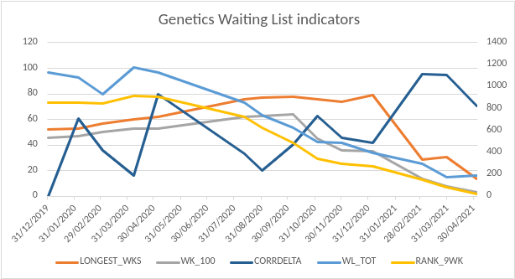

Data table:

|  |  |  |  |  |  |
| --- | --- | --- | --- | --- | --- |
| **DATE** | **WL_TOT** | **LONGEST_WKS** | **WK_100** | **RANK_9WK** | **CORRDELTA** |
| 31/12/2019 | 1130 | 52 | 46 | 857 | 0.00 |
| 04/02/2020 | 1086 | 53 | 47 | 854 | 60.80 |
| 03/03/2020 | 930 | 57 | 50 | 848 | 36.00 |
| 07/04/2020 | 1176 | 60 | 53 | 916 | 16.00 |
| 05/05/2020 | 1127 | 62 | 53 | 909 | 80.00 |
| 11/08/2020 | 855 | 76 | 62 | 728 | 33.43 |
| 01/09/2020 | 742 | 77 | 63 | 622 | 20.00 |
| 06/10/2020 | 626 | 78 | 64 | 490 | 40.80 |
| 03/11/2020 | 496 | 76 | 45 | 343 | 63.00 |
| 01/12/2020 | 484 | 74 | 36 | 296 | 46.00 |
| 05/01/2021 | 398 | 79 | 35 | 271 | 41.60 |
| 02/03/2021 | 296 | 29 | 14 | 149 | 95.56 |
| 30/03/2021 | 172 | 31 | 8 | 86 | 95.00 |
| 04/05/2021 | 188 | 14 | 3 | 26 | 70.40 |

Note: there is a gap in the data from May 2020 to August 2020 – I have not been able to locate these specific files, so two data points (June and July) are missing. However the data can still be interpolated across these gaps, and the trends are largely uninfluenced.

There is an apparent dip in the overall size of the waiting list at the start of March 2020, but without a corresponding dip in the number of patients waiting >9 weeks. This seems to be an artefact caused by incomplete data capture, and demonstrates the value of using different techniques to visualise the data.

## Referrals over the Pandemic

In common with many other services, referrals to Genetics showed a significant fall over the Pandemic. Pre-pandemic, referrals averaged around 3800 per year. In total, in FY 2020-2021 referrals were approximately 40% down overall. Although we have not yet looked at this data in detail, initial impressions are that this mostly affected referrals from primary care for family history of cancers. Cancer family history patients are normally seen by the Genetic Counsellors, and consequently do not normally contribute to the overall Genetics Consultant-led PTL waiting list backlog.

Notably, from December 2020 onwards, referrals have increased again (as anticipated), and in March were back close to the pre-pandemic range. We are continuing to monitor these trends.

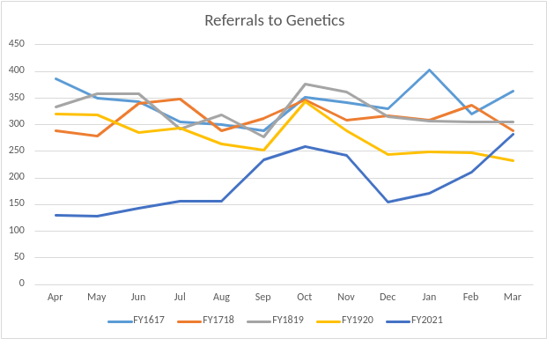

## Threats to sustainability

While the data we present here show a considerable improvement on the pre-pandemic picture, and our insights may have broader applicability to other service areas, it is worth remembering that different service areas have different problems and different factors impacting on their waiting list backlogs.

Also, as we move into a post-pandemic phase there are certain things that may work against sustaining a healthy waiting list position.

1. **Lack of accommodation:** The Genetics Service is extremely pressed for space (both labs and clinical). This was exacerbated by the need to socially distance and work more separately over the Pandemic, but is offset somewhat by several staff being able to work from home, at least part of the week. While working from home, as with virtual clinics, is likely to be a part of how we do things from here on in, lack of space continues to be a major problem. For example, we have exhausted notes storage space, and also our seminar room, which is sorely needed for staff education and MDTs, has had to be converted to admin desk space.
2. **Review backlog:** Many non-urgent Review patients have had their appointments postponed until after the pandemic. This is likely to cause pressure on clinic slots, meaning the New Patient waiting list may grow again.
3. **NHS England Test Directory:** Many genetic tests are changing to Whole Genome Sequencing in the future. Discussions are ongoing with the Department of Health and HSCB as to how we might afford this for our patients, but the consent and sampling processes for these tests are highly complex and will take a considerable amount of time to administer. This will make appointments longer, impacting the number of patients we can see. Similar expansions of genetic technology in other areas may also have an effect.
4. **Staffing:** A retired Consultant Geneticist was unable to be replaced, so we are one consultant down. Additionally, increased requirements for MDTs with other specialties (a very welcome development that will definitely see benefit for patients) puts pressure on staff job plans.

## Conclusion

We have described some of the steps we took in Clinical Genetics to address our New Patient waiting list backlog over the Pandemic. We employed several different techniques, often simultaneously, each representing a Good Thing To Do, but in a context that makes it difficult to determine the relative contribution of each one. That said, our approach was highly successful in reducing our waiting list to a manageable level, with the caveats that this was in the context of reduced referrals, and that many patients will need reviewed post-pandemic.

However a very important point is that **we did not treat our waiting list backlog as a black box**. We made the data visible to staff so that we could seek out the quick wins. **We did not put more staff at the end of the process, unloading the sausage machine**. Rather, we had visibility over the process and engagement – almost gamification! - of improvements in the waiting list. This has had the result that patients referred to Clinical Genetics are receiving assessment and management much faster than before the Pandemic.

While each service area and specialty is different, and faces its own challenges, we have shown that delving into the data and searching for quick wins is an effective approach at getting to grips with out-of-control backlogs. While we did this manually, the prospect exists for using data techniques such as artificial intelligence and machine learning to optimise processes further, and we recommend that this is explored further by the Trust and the Region, so that we can start to solve the awful problem of Northern Ireland’s waiting list backlog. In particular, several of the waiting list health indicators I have mentioned in this document may be applicable (in original or revised form) to other waiting lists. There may be particular limitations in applicability to backlogs where procedures are required (e.g. surgical), rather than a clinic appointment. It is clear we will need to continue to come up with solutions suitable to specific areas.

## Acknowledgements

My thanks to Dr Tabib Dabir, Clinical Director and Clinical Lead prior to July 2020, Dr Gillian Rea, Clinical Lead (Cancer Genetics) from July 2020, Ms Sianan MacParland (Lead Genetic Counsellor), Dr Clodagh Loughrey (Divisional Chair, Pharmacy & Labs), Dr Shirley Heggarty (Head of Genetic Laboratories, NIRGS), Mr Laurence Tucker (Service Manager), Mrs Jena Crawford (Co-Director) and all the staff on the clinical, laboratory and admin sides of the NIRGS. This was very much a team effort, in the context of the lab diverting staff and facilities to assist with Covid work, and some members of medical and Genetic Counselling staff manning the Virtual Covid Hospital, Proning Team and the Vaccination Service.

* Dr Shane McKee, Consultant in Genetic & Genomic Medicine (Clinical Lead, non-Cancer Genetics), CCIO, BHSCT.